SYSTEM DOCUMENTATION

Project Name: DataMaster

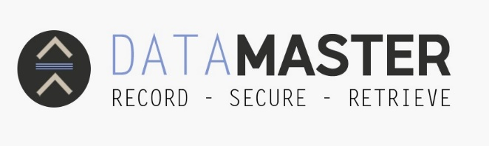

ABSTRACT

The main purpose of developing this web application is to help companies to be able to track visitors that are coming in and going out of their building per day. Most companies they use hard copy form to capture details of their visitor, before allowing them to access the building.
The Data master application will solve this kind of problem of filling hard copy form by registering a visitor’s details in the system using the tablet device of a company. The system can keep the details of the visitor in the system’s database to avoid visitors to register more than once.

TABLE OF CONTENT

ABSTRACT I
TABLE OF CONTENT II
INTRODUCTION 1
PROBLEM 1
SOLUTION 1
PROJECT AIM AND OBJECTIVES 1
DESIGN CONSTRAINTS AND ASSUMPTIONS: 2
SYSTEM ARCHITECTURE 2
FUNCTIONAL REQUIREMENT AND NON-FUNCTIONAL REQUIREMENTS 3
SYSTEM DESIGN/ RUNTIME INTERFACE REQUIREMENT 4
USE CASE DIAGRAM 5
USER INTERFACE 5
ACTIVITY DIAGRAM 11
POPIA 15
ACTIVITY DIAGRAM 16
DEPLOYEMENT DIAGRAM 18
SUMMARY 18
CONCLUSION 18
REFERENCES 19

INTRODUCTION

Data Master Application is a responsive web application developed for the companies to track visitors entering their building. The visitors will have to register her/his details in the system using company’s electronic device. The technologies used in this system are MYSQL Database and the programming languages used is JavaScript and PHP. This system is for transforming the current long process system of filling hard copy form used to register visitors before they enter the building of any company.
The visitor register his/her details once in the system. In the system there is an admin part where the admin can view the number of visitors that visit its company.
The admin as well will have to have a profile to view all the visitors in the system. The application will help the visitors to be able to visit any company using it.

PROBLEM

Many companies they use hard copy forms to register the details of their daily visitors before they allow them to enter their building. The main disadvantage about these forms is that even if a person visited yesterday, the next day that visitor comes back is required to register her details again in the new form again.

SOLUTION

The problem we have encountered needs a solution that is innovative and flexible. We decided to develop a web application that will help companies to track visitors that need to enter into the company’s building. Our system can enable the company to be able to register/sign in its visitors using this system when tracking visitors that are entering its building.

This system is time saving, since a visitor register once on it. Then the next time a visitor come back again to visit, it can just sign in, instead of registering his/her details again.

PROJECT AIM AND OBJECTIVES

Aim
We created this web application in the aim of assisting companies from upgrading their system of using hard copy forms when they register their visitors before allowing them to enter their building.
Objectives
- To create Data Master Application that will manage appointments of a visitor and a company.
- To provide company and visitors a platform to manage their meetings.
- The application should be able to collect and save all the visitor’s details.

DESIGN CONSTRAINTS AND ASSUMPTIONS:
Constraints for the user
- The interface will be in English only.
- The system does not cater to users who have disabilities e.g., text to speech for people who have eyesight problems.
- The system is a single-user system.

Constraints for the developer
- The developer must understand how to use any source code editor.
- It must understand JavaScript, PHP, HTML and CSS3.
- It must understand one of the operating system
- It must understand how to make the app fit in all screen sizes.

Assumptions
- Users must have basic knowledge of navigating through the systems.
- The user must have basic knowledge of English.
- Users must have internet access on their computers that they use.

SYSTEM ARCHITECTURE

System Hardware Architecture
Mobile device and Desktop - These devices will enable our system to run in both mobile as for the visitors who will register or sign in, in the system, and desktop for admin for viewing registered users.

Database server – These are the servers that we will use to deploy our database also host and maintain it.

FUNCTIONAL REQUIREMENT AND NON-FUNCTIONAL REQUIREMENTS

After analysing the data, we formulated several requirements namely user requirements, system hardware and software attributes. These were grouped as user, functional, non-functional and runtime interface requirements.

Functional and Non-functional Requirements

The requirement specifications
Requirement specification describes what the system must do to meet conditions for tracking visitors before they enter any company’s building. It must have functional requirements, basic behaviours of the system, and non-functional requirements which determine all the attributes of the app.
Functional requirements of the app
The visitor’s interaction
- The app allow visitors to create their profile on the company’s mobile device.
- The app allow visitors to retrieve on it.
- The application allow visitors to fill a form for visiting.
- The app allow each visitor to view his/her details.
- The app allow a visitor to sign out in the system.

The Admin interaction
- The app allow an admin to create a profile.
- The admin can be able to log in.
- The admin is able to view all the registered visitors.
- The system can allow the main admin to add other admin.
- The system can allow admin to view the history of the visitors.
- The admin can view the current log in visitors.
- The admin can view signed out visitors
- The app allow the admin to be able to search for any visitor.
Non-functional requirements
Non-functional requirement includes the following:
- The system must verify the validated user input and the user must be notified in case of errors detected in the database, the system should allow room for expansion.
Usability
- This app will run on all screen sizes for all mobile devices and desktop computer.
- This app will work on any operating system.
Reliability
- This app will perform specified functions without crashing as we check exceptions and log them.
Maintainability
- We will be able to update the app without losing any data.
Performance
- The app will work accurately and effectively.
- The app will load faster and smoothly as we catch the data.
Security and availability
- The user’s sensitive data will be encrypted and protected.
- The app will be available online 24/7.

SYSTEM DESIGN/ RUNTIME INTERFACE REQUIREMENT

This section describes the hardware components and software components needed for the effective and efficient running of the system.
Hardware Requirement
Hardware | Minimum System Requirement
Processor | 2.4 GHz Processor speed
Memory | 4 GB Ram
Disk Space | 500 GB

Software Requirement
Software | Minimum System Requirement
Operating system | Windows 10, Mac, Linux
Database Management system | MYSQL
Runtime Environment | Source code editor

USE CASE DIAGRAM

The following is the use case diagram which describes all the attributes of the application.

USER INTERFACE
Inputs
One of the popular input media used by our system to retrieve data for the user is the mobile touch screen keyboard input and Desktop keyboard, mouse and touchpad media which will be used by visitors and Admin to type in data into our system.

Interface
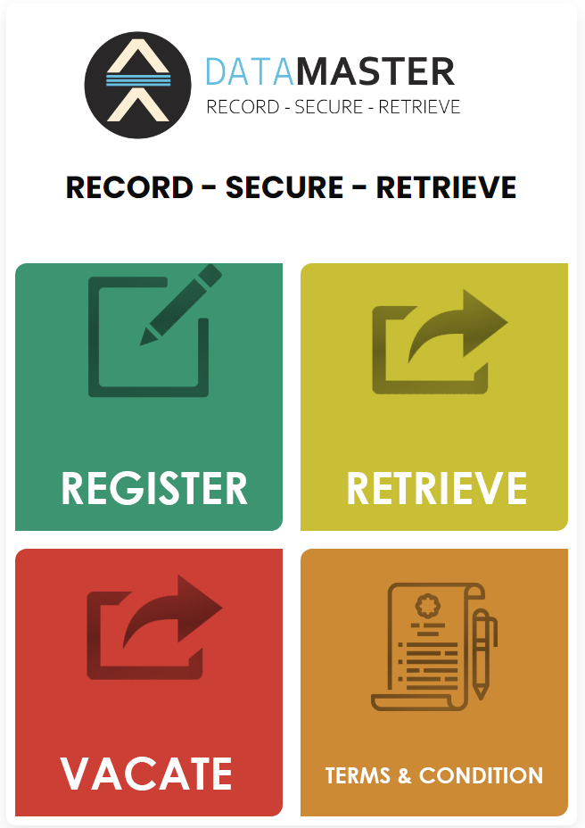
This is the home page for the visitors to register in the system or retrieve in the system. They can read terms and conditions and they are able to sign out.

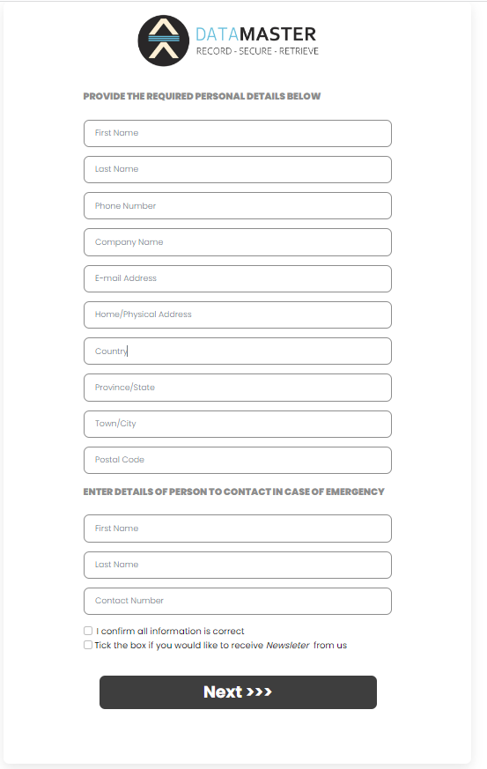

This is the page that appear when the visitor click register button. Here the visitor must fill his/her personal details in the form as shown in order to be registered in the system. Then click the next blue button to register herself/himself in the system.

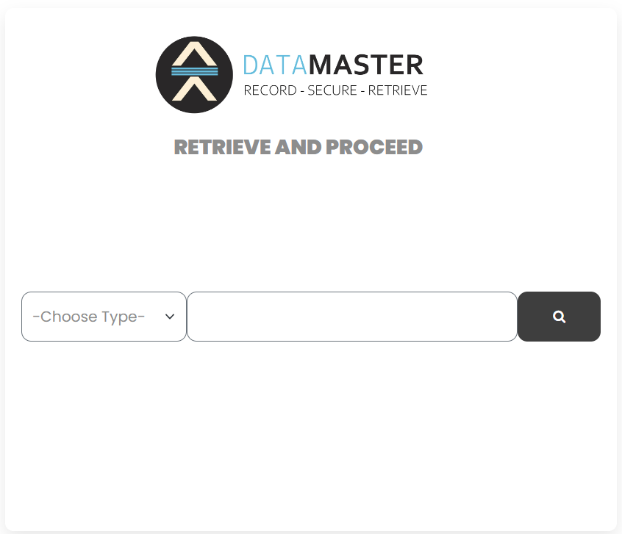

The above page is the retrieve page where a visitor can put his/her contact number/email address to view if he/she is existing in the system.

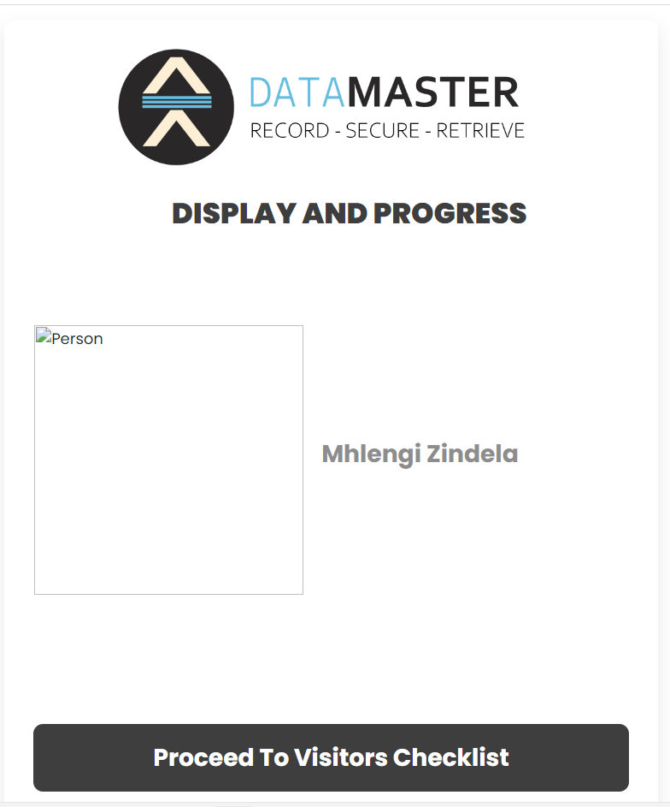

The above page is the page that shows an image and names of a visitor. This page only appear when a visitor is already registered in the system.

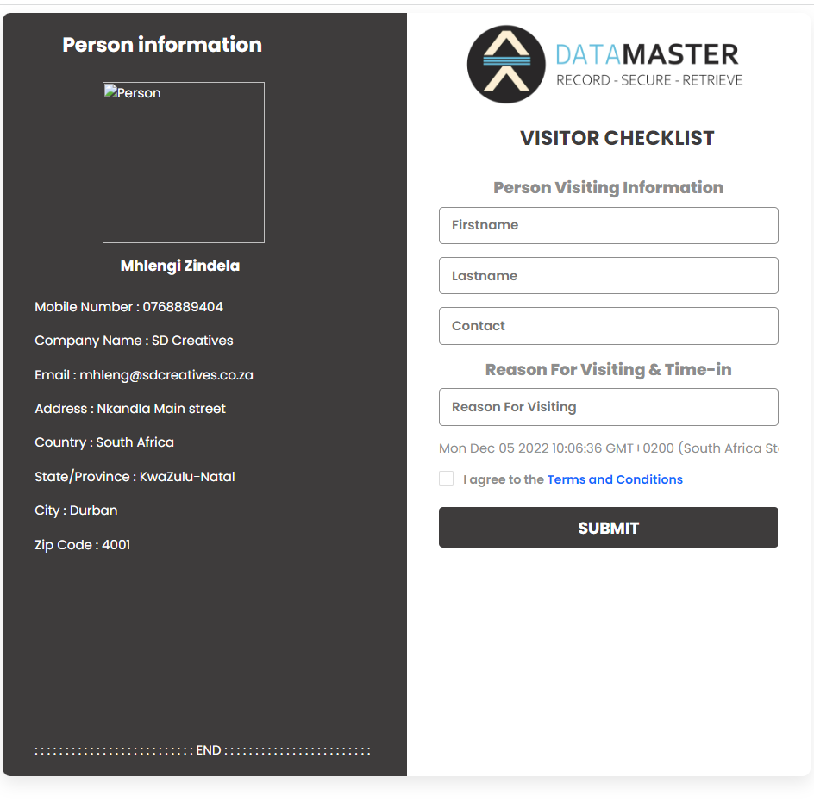

The above page is the page where a visitor can fill the Covid-19 status form in the system, to check if he/she had Covid-19 or not. After submitting this form he/she can now get inside the company’s building.

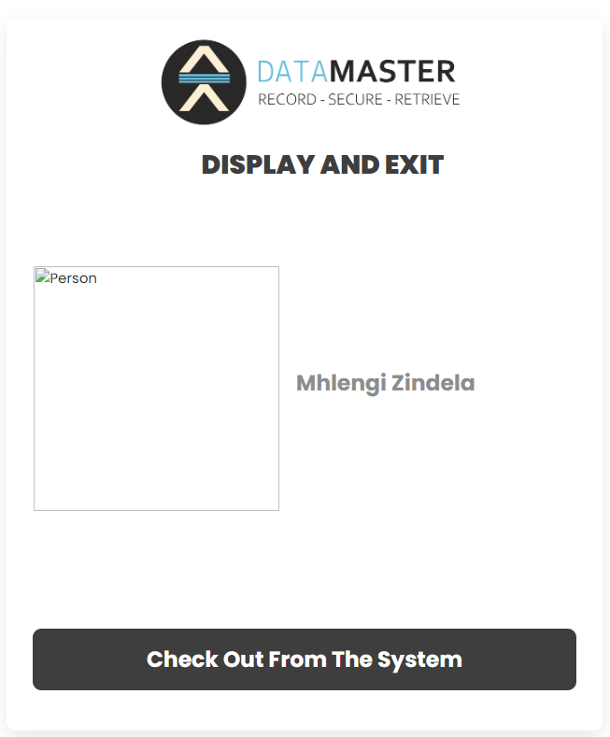

The above page is the page that can allow a visitor to sign out to the system.

ACTIVITY DIAGRAM

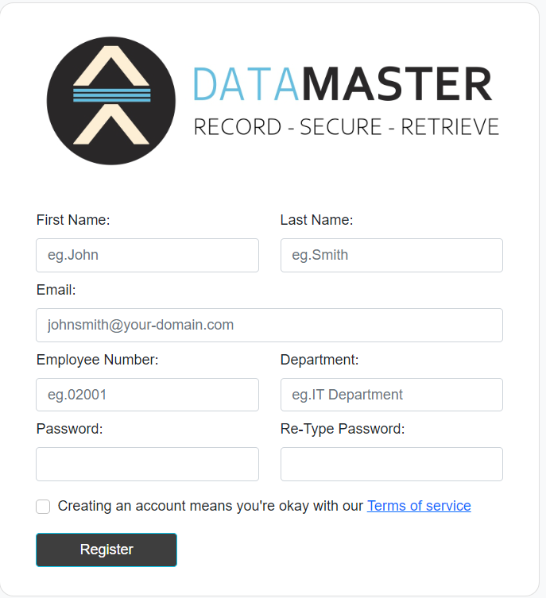
The above page is the page where the admin can register himself/herself in the system.

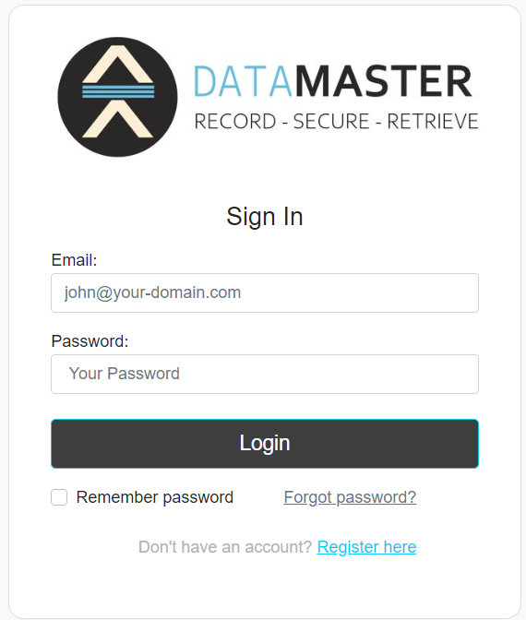
This is the login page that the admin can use to sign in in our system.

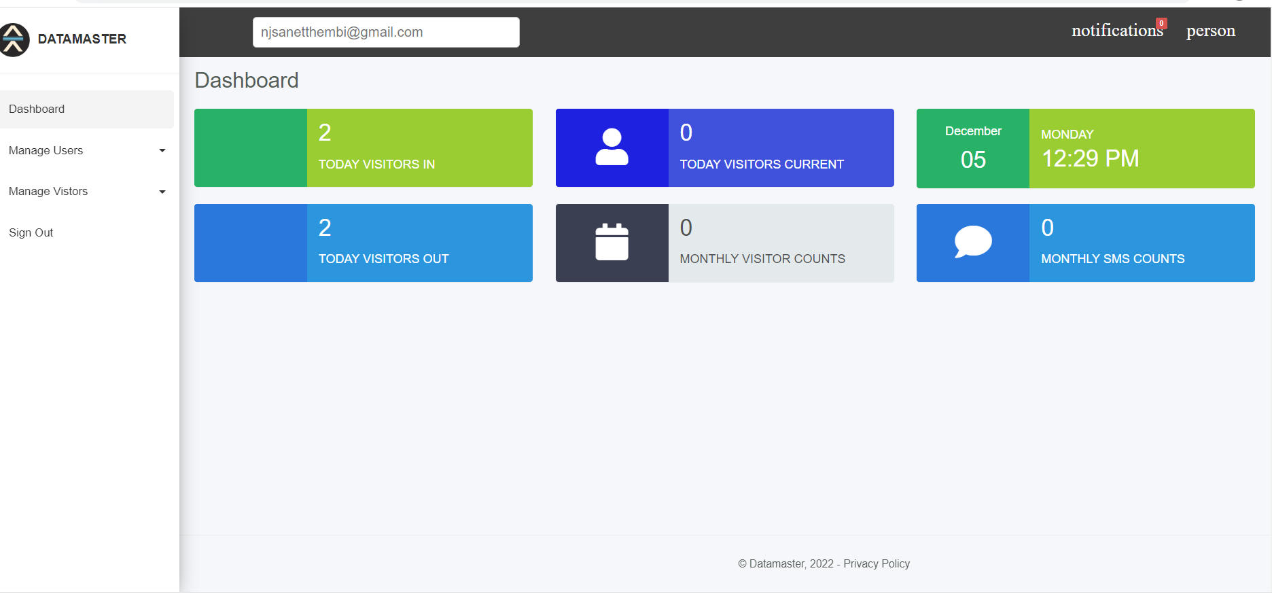
This is the admin dashboard where she or he can perform certain tasks. Task like viewing active visitors, history of visitors, adding other admin.

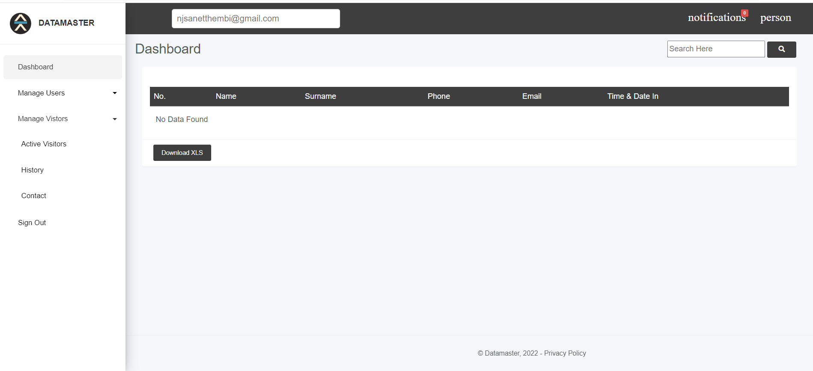

This is the page that displays active visitors that are still in the building.

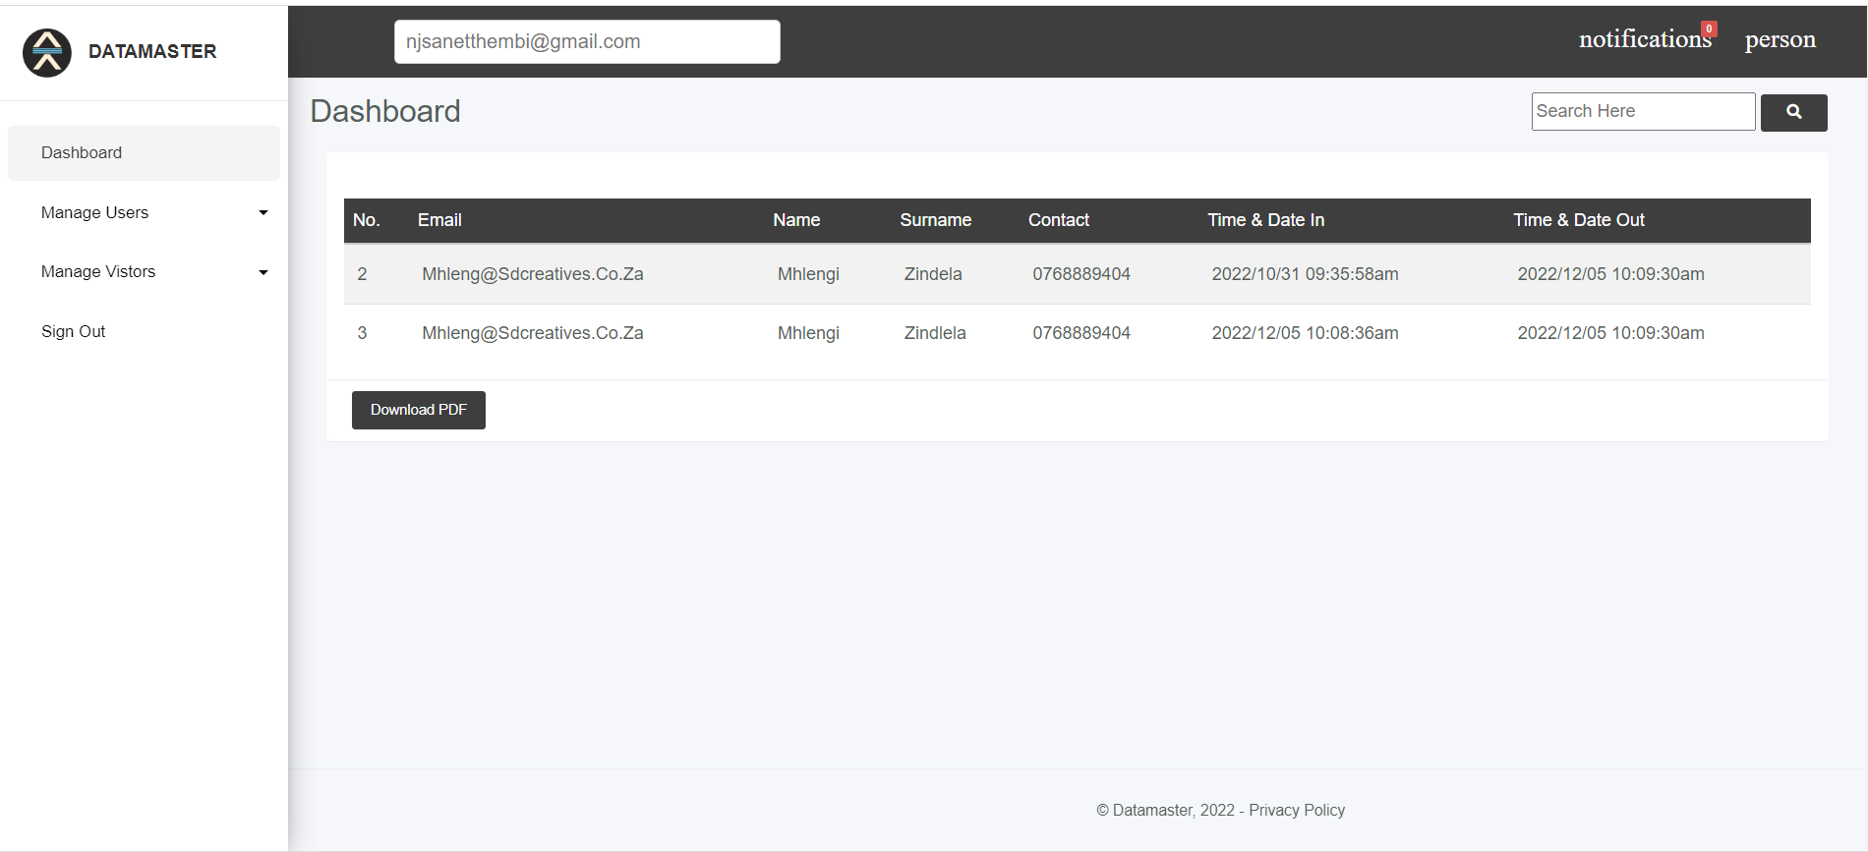

This is the page that displays history of all visitors that were visited certain company.

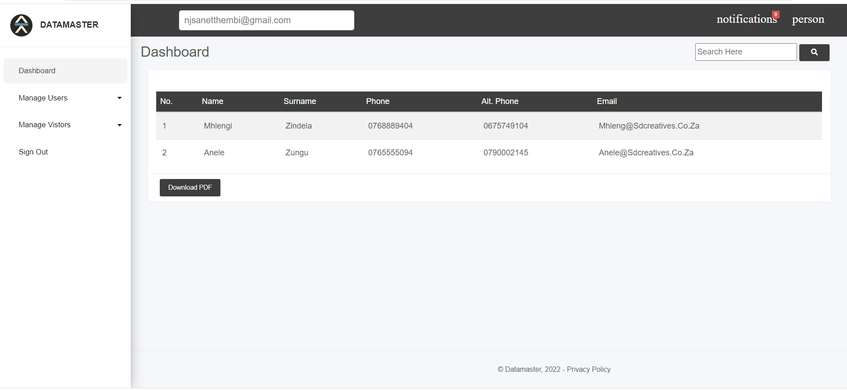

This is the page that displays contacts of the visitors that were visited certain company.

POPIA

As our system will flow online where it can be reached by the public. We will make sure that sensitive information of the users like password will be encrypted. We will make sure that when the user is signing in the system. The user will receive an email or an SMS that tells if he/she is the real user or not.

ACTIVITY DIAGRAM

This is the diagram that shows the decomposition of the system

DEPLOYEMENT DIAGRAM

This is the diagram that determine our system’s implementation stage

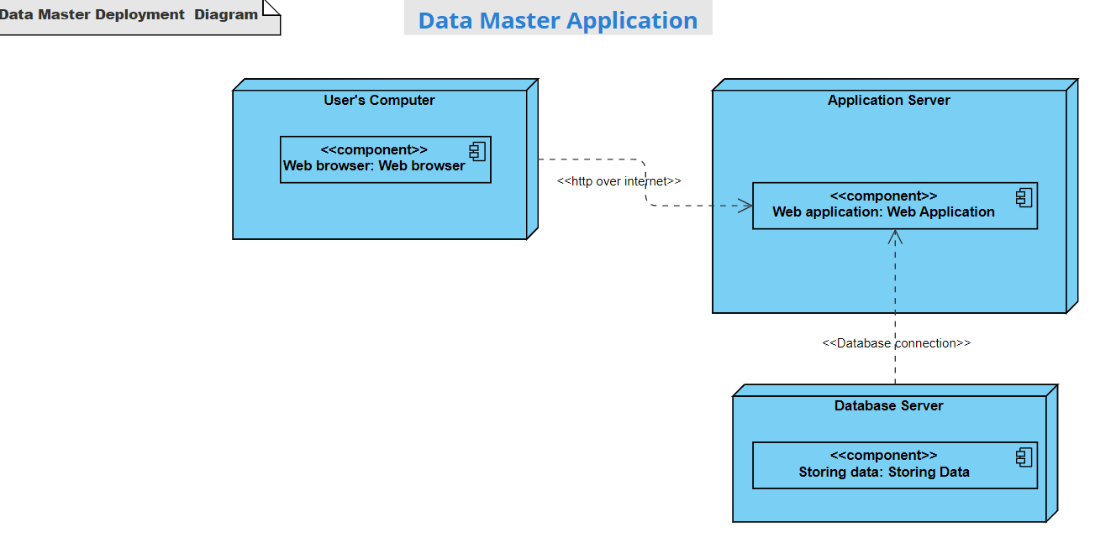

SUMMARY

I and my team, we developed a very innovative system that will make it easier for the companies to allow visitors that they need to visit their companies. Our system is able to register and sign in visitors electronically to the company they visited before they enter the building.

This system will also help anyone who needed to visit any company for some important needs. This system is important and it could be a valuable asset. Since the company will use a mobile device to sign in visitors instead of using hard copy forms.

This application can save time and other physical resources that a company can use to track visitors in and out of the company’s building. Since the system is a computer based system that can work on any kind of computer that a company can afford as long the computer can access the internet.

CONCLUSION

The core reason for the establishment of Data Master is to enable companies to be able to track visitors that need to enter their company’s building. The Web app will enhance the visitors' experience by offering them a most convenient way of consulting and engaging with the companies. This app has successful met all the requirements of visitors and the company.

REFERENCES
https://www.w3schools.com/php/default.asp
database-systems-design-implementation-carlos-coronel(www.ebook-dl.com)

